Ash’s Favorite North Alabama Trails

When most think of Alabama, tourism is not usually the first thing that comes to mind. Let’s face it, people don’t often visit Alabama unless they’re visiting our South Coast beaches. What people don’t realize, however, is that North Alabama has a variety of attractions spanning the entire width of the state. In this piece, I’ll explore quite a few, but nowhere near all, of the attractions found here in Sweet Home (North) Alabama! Here are some of my favorite trails…

## Wineries, Craft Beer, and BBQ Trail

Everyone’s gotta eat, and most enjoy a sweet glass of wine or a delicious, unusual craft beer. North Alabama has a plethora of wineries, craft beer breweries, and delicious Southern BBQ. Here’s a few, but there’s plenty more so that you can make a long weekend out of just this trail!

1. **Sipsey Vineyard and Winery**

Found deep in Bankhead National Forest in Winston County, Sipsey Vineyard and Wines craft quality wines and ciders in wooden barrels. They offer wine tastings and wine for purchase. Visit them at 24972 Hwy 195, Double Springs, AL or check them out online at [www.sipseywine.com](http://www.sipseywine.com).

1. **Jules J. Berta Vineyards**

Located at 1409 Darden Ave in Albertville, this vineyard boasts a 22-acre farm with stunning views from the top of Sand Mountain. Jules focuses mainly on Chardonnay, Cabernet Frac and Merlot, but Jules also has fruit wines available. And the fruit is grown by local Alabama farmers!

1. **Maraella Winery**

Founded in 2005 in the Appalachian foothills in Hokes Bluff, Alabama, this vineyard grows and bottles their own Cabernet Sauvignon. Maraella’s offers a complimentary wine tasting and tour with a gift shop where visitors can find a great selection of cheese and novelties.

1. **Yellowhammer Brewing**

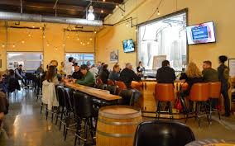

Located at Campus 805 in Huntsville, Yellowhammer Brewing offers not only a brewing space, but also a Biergarten and Event Center. They are dedicated to creating premium ales and lagers, drawing on Belgian and German traditions, with a Southern interpretation. Find them at 2600 Clinton Ave W.

1. **Back Forty Beer Company LLC**

Located at 200 N. 6th Street in Gadsden, Back Forty Beer Company sources their ingredients locally. Tour the microbrewery or hang out in the taproom to try delicious craft beer like Truck Stop Honey Brown. Plan your visit online at [www.backfortybeer.com](http://www.backfortybeer.com).

1. **LawLer’s Barbecue**

Serving North Alabama since 1978, LawLers offers an array of smoked meats, southern sides, and incredible desserts. My family and I eat here at least once a month! They have locations across North Alabama, including in my hometown! LawLers offers dine-in, carry-out, delivery, and catering. For those with gluten-free or keto diets, LawLer’s has something for you, too. Visit their website to find a location near you!



## Museum Trail

Scattered across North Alabama is a trail of museums and historic sites. As a North Alabama native and a TOTAL sucker for museums, here are some of my favorite ones to visit:

1. **U.S. Space and Rocket Center**

This is hands-down my favorite museum in North Alabama! I am a space NERD! Located in Huntsville, the city that sent America to the Moon, the USSR has the world’s largest collection of space memorabilia. Enjoy the interactive simulators, the NatGeo IMAX theatre, and the Intuitive Planetarium. Visit [www.rocketcenter.com](http://www.rocketcenter.com) for a complete list of daily special activities. My favorite is Cocktails and Cosmos on Friday nights! Enjoy a space-themed cocktail and listen to a phenomenal interactive lecture about the cosmos!

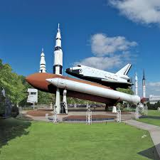

1. **Jesse Owens Museum**

In 1936, Alabama native and black man Jesse Owens won 4 Olympic gold medals in the Berlin Games and crushed Hitler’s Aryan race supremacy theory. The Jesse Owens Museum in Danville is dedicated to Owens’ athletic and humanitarian achievements. Visitors can learn about Owens’ life through interactive kiosks, displays, memorabilia, and a rare documentary that is narrated by Jesse Owens himself! To plan your visit, go to [www.jesseowensmuseum.org](http://www.jesseowensmuseum.org) or call 256-974-3636.

1. **Helen Keller Birthplace**

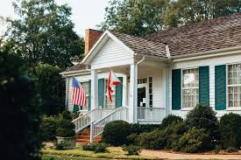

Built in 1820 and located in Helen Keller’s hometown of Tuscumbia, Ivy Green contains many of the original items and furnishings involved in the life of Helen Keller. Visitors can learn about the life of Keller, her family and her famous teacher, Anne Sullivan. Visit helenkellerbirthplace.org for admission information.

1. **Alabama Veterans Museum**

Voted as an Attraction of the Year in Alabama by the Alabama Mountain Lakes Tourist Association, the Veterans Museum has a large exhibit of artifacts from the Revolutionary War up to the present day. Veterans and their families have donated everything in this collection, and local veterans provide guided tours of the museum. On the first Saturday of each month, the museum hosts Coffee Call in which local veterans and their guests meet for camaraderie and fellowship. Drawing over 10,000 visitors last year, this is must-see in Athens.

1. **FAME Recording Studios and Alabama Music Hall of Fame**

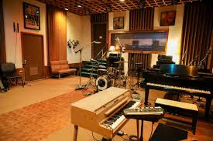

Founded in 1959 in Muscle Shoals, FAME Recording Studios was the first successful professional recording studio in Alabama. Many a great artist from all genres of music have recorded here, including Hank Williams, The Temptations, Aerosmith, and more! FAME is still an operational music studio and offers limited tours Monday-Saturday. Call

256-381-0801 to schedule your tour.

After you visit FAME, travel just up the road to Tuscumbia to visit the Alabama Music Hall of Fame to discover the stories of some of the world’s most famous musicians, born right here in AL!

## Waterfall, Cave, and Park Trails

For the outdoor adventurers, North Alabama offers a substantial number of waterfalls, caves, and parks to explore. Home to multiple State Parks and a National Forest, North Alabama is an outdoor enthusiast’s dream!

1. **Waterfall Trio on Lookout Mountain**

Featuring three falls, the Waterfall Trio on Lookout Mountain in Fort Payne is a spectacular sight! DeSoto Falls is one of the tallest in the state and features several smaller falls. Built above DeSoto Falls in 1925, is a concrete dam that was used for Alabama’s first hydroelectric power plant.

Little River Falls can be found at the north end of Little River Canyon National Preserve—14,000 acres of beautiful scenery.

The seasonal Grace’s High Falls can also be found within the Little River Canyon Preserve. At a stunning 700 feet tall, this waterfall offers a wonderful view from the top.

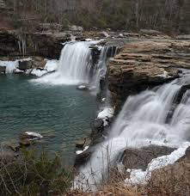

1. **Noccalula Falls Park**

Located in Gadsden, Noccalula Falls is over 90 feet tall and is one of the most visited natural attractions in Alabama. Noccalula Falls Park includes attractions for the whole family, complete with botanical gardens, a sightseeing train, a playground, and much more! Visit [www.noccalulafallspark.com](http://www.noccalulafallspark.com) for a complete list of park attractions.

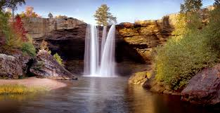

1. **Cathedral Caverns**

An official State Park of Alabama, Cathedral Cavers is nestled in Woodville, Alabama. Its huge opening holds a possible world record for commercial caves. Inside, the Caverns holds another world record for Goliath, one of the largest stalagmites in the world, coming in at a whopping 45 feet tall and 243 feet around! Open daily for scheduled tours. Call 256-888-0230 to book your reservation.

1. **Rickwood Caverns**

Rickwood Caverns is another official state park in North Alabama, and an official member of the National Caves Association. Located in Warrior, Rickwood Cavers boasts 260-million-year-old limestone formations and an underground pool. See the fossils of marine life and shell fragments along the cave’s ceiling and walls. Rickwood Caverns contains living formations built by mineral-filled water droplets. Call

205-647-9692 to book your guided tour.

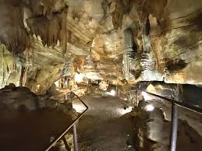

1. **Huntsville Botanical Gardens**

At 4747 Bob Wallace Avenue in Huntsville, you’ll find 118 acres of splendid beauty. With a Nature Center, Butterfly House, and Children’s Garden. Huntsville Botanical Gardens invites their visitors to experience a variety of ecosystems. Throughout the year, the Gardens offers a variety of different seasonal exhibits: the Scarecrow Trail, Golden Hour, and my favorite, the Christmastime Galaxy of Lights. Go to [www.hvbg.org](http://www.hvbg.org) for ticket, tour, and exhibit information.

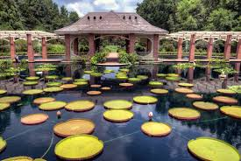

1. **Bankhead National Forest and Sipsey Wilderness**

North Alabama may be home to an abundance of State Parks, but it is also home to this 180,000-acre National Forest. Just a mile north of Double Springs, Alabama, Bankhead has a plethora of sights to see, including bluffs, canyons, and waterfalls. Bankhead also offers six recreational areas that have a variety of activities for guests to enjoy. For questions, call 205-489-5111.

## North Alabama Motorcycle Trails

I love hopping on our motorcycle with my husband and going for a ride, so for those of you like me who love feeling the wind in your hair and breathing fresh Southern air atop two wheels, here are a couple of great motorcycle trails right here in North Alabama.

1. **Natchez Trace Ride**

From the Tennessee State Line, 33 miles through North Alabama, to the Mississippi State Line, Natchez Trace displays brilliant colors in the spring and fall.

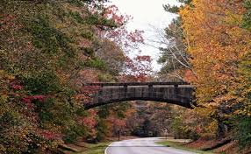

AL-20 on Natchez Trace

1. **Covered Bridge Trail**

Blount County is known as the Covered Bridge Capitol of Alabama. Three covered bridges remain in the county today. With hills and tree-lined, curvy roads between the bridges, the Covered Bridge Trail is a biker’s dream.

* Swann Bridge is the longest covered bridge in the South at 324 feet long.
* The Easley Bridge is the oldest of the three bridges, built in 1927. Only 95 feet long, this covered bridge is 14 feet wide and a mere 18 feet above the river.
* Horton Mill Bridge was built in 1935 and towers 70 feet above the Warrior River, earning the title of being the highest covered bridge above water in the entire United States. Horton Mill Bridge was the first covered bridge in the South to be added to the National Register of Historic Places.

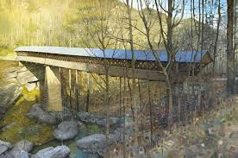

Horton Mill Bridge

As a North Alabama native, I’ve visited most of the attractions that I’ve featured here, and they are nothing short of incredible sights. North Alabama has so much to offer in the way of tourism—I’ve only barely scratched the surface here. If you’re interested in these and other attractions, (there’s many more like the art and mural trails, the bass trail, golf trail, and so many more), check out [www.northalabama.org](http://www.northalabama.org) for a comprehensive list of North Alabama attractions and events.